Saving The Hungry Nepal

Day One
Welcome to Kathmandu the capital of Nepal. Upon arrival, you will be picked up by a local transportation company that will take you to the grass roots Not For Profit we work with. Our project is located on the outskirts of Kathmandu.
The architecture in this great country is fascinating but be prepared for the rubble and poverty. The contrasts that hit all your senses in Nepal are fascinating: the sounds, smells, views and overall feeling of being in another world.
Kathmandu is situated in a valley full of historic sites, ancient temples and shrines, golden pagodas and interesting villages.
Your volunteer accommodation for the next 4 days is simple but clean with no air conditioning. This is not a 4-star experience!
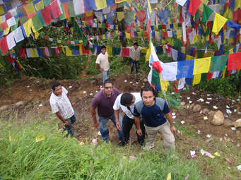
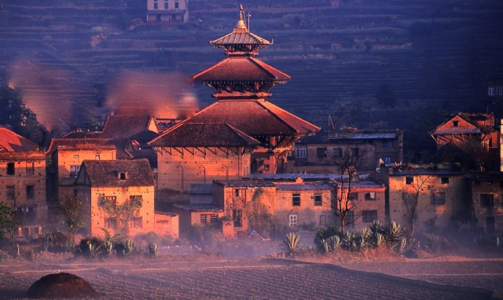

Day Two, Three, Four and Five
Nepal is a landlocked country located on south east of Asia. It is the poorest country in South Asia and ranks as the twelfth poorest countries in the world. Over 40% of Nepalese live on less than $14 per person, per month.
Over 80% of the population in Nepal live in rural areas and depend on farming to survive. These families have no access to health care, education, clean drinking water and sanitation. Half the children under the age of 5 have malnutrition and for every 1000 babies born in Nepal, 29 dies before their first birthday.
Your volunteer experience will be spent working helping to build an orphanage along with participating in their feeding program.
After the 2015 earthquake that left almost 9000 people dead and many children orphans Mission Napel took children living in the streets in and gave them a home.
Until the orphanage is completed these children live in foster homes which is not idea but it gets them off the street and away from sex traffickers. Currently 40 children (ages 3 ½ to 12) are living with various foster partners that are struggling to care for their own children. Resources are stretched and everyone goes with a little less.

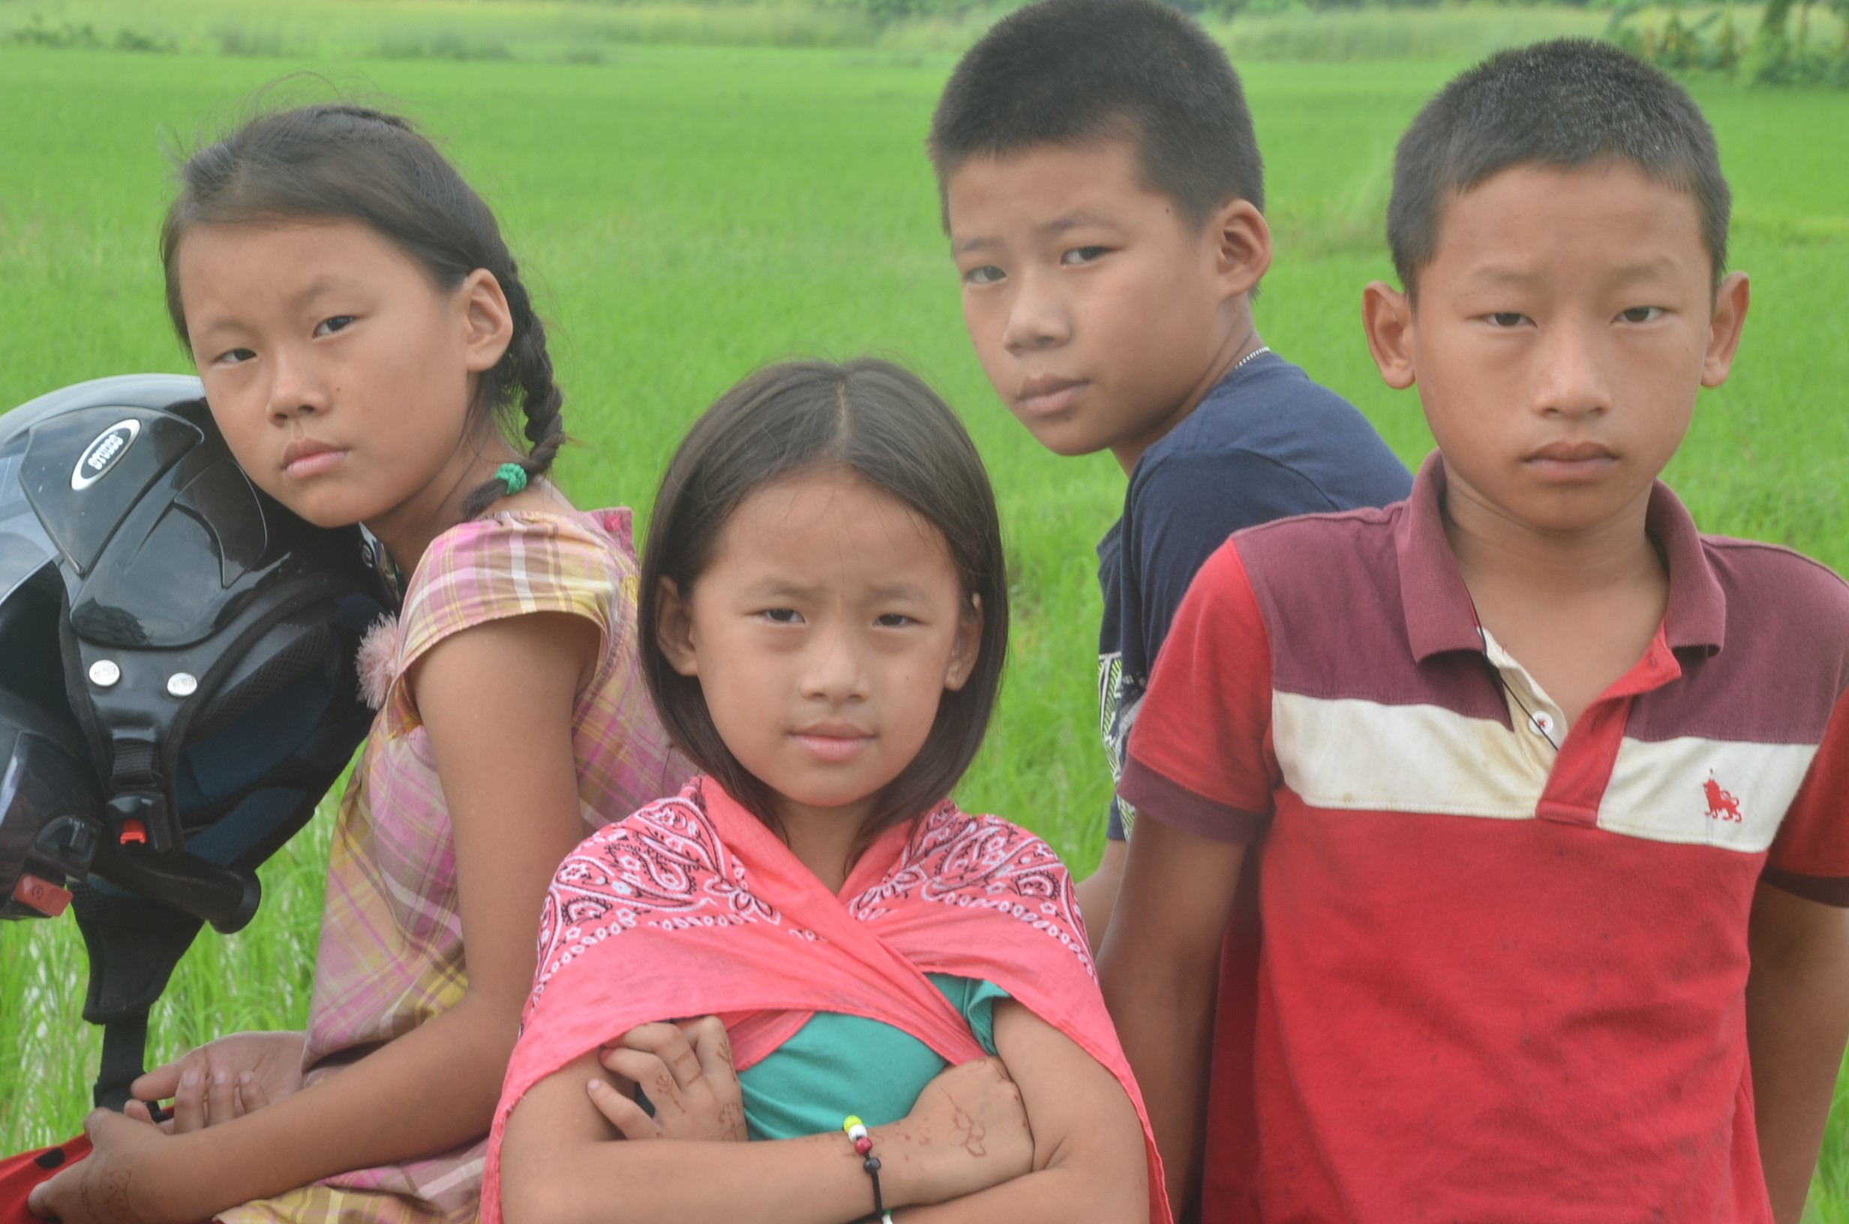
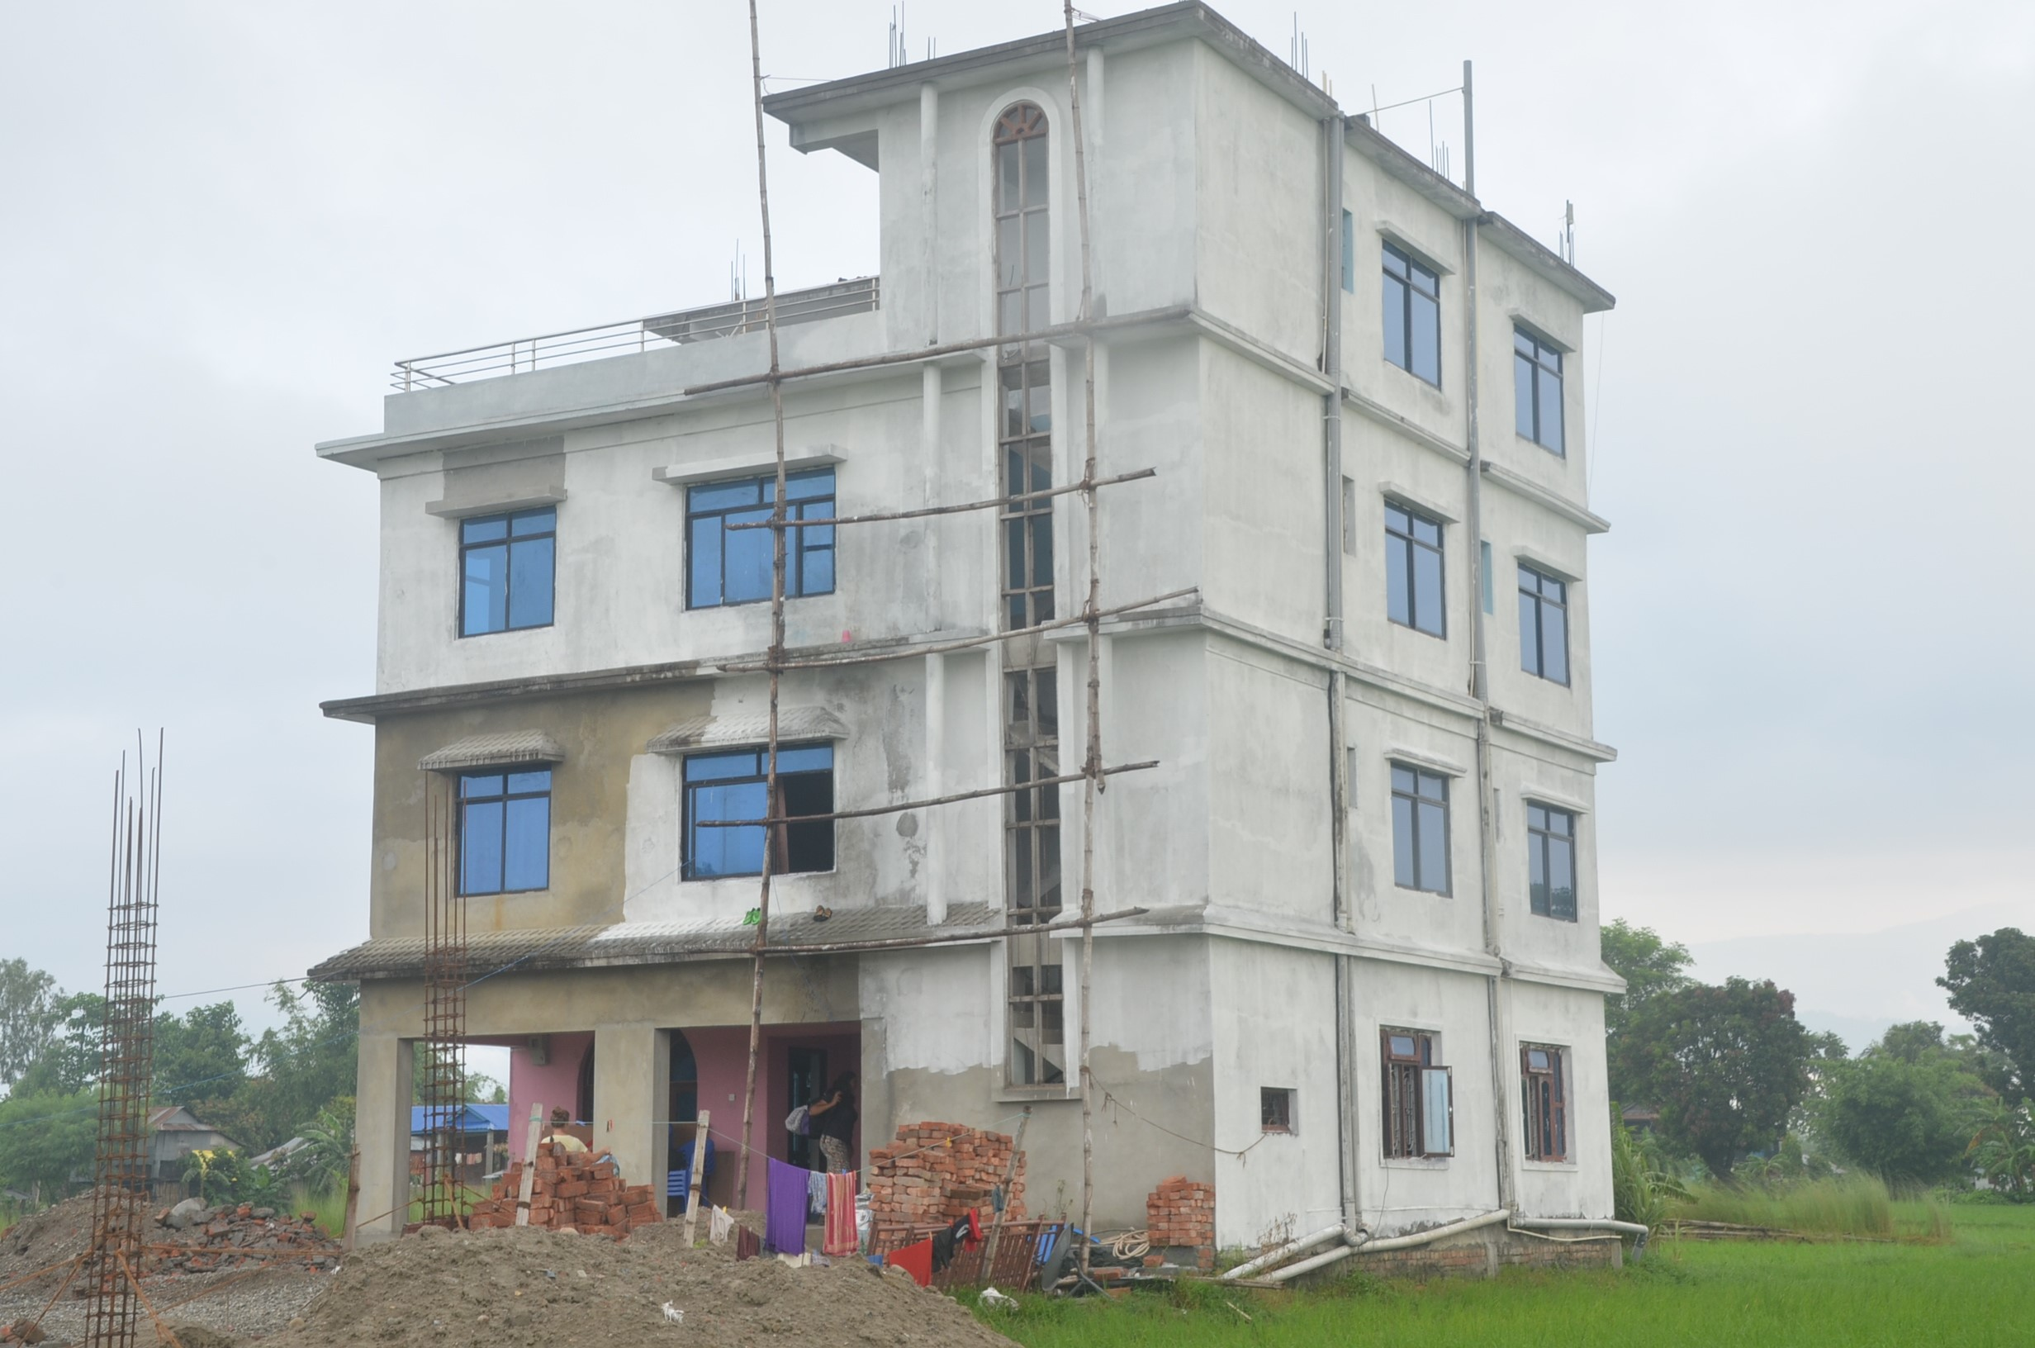

Day Six
After breakfast, you tour to explore the city of Bhaktapur, the village of Nagarko and the Kathmandu Valley to experience the local life of the Nepali people. You will learn about Kathmandu's rich culture and visit the Kathmandu Durbar Square, the temple of Swayambhunath and Patan City (about 15 min by bus)
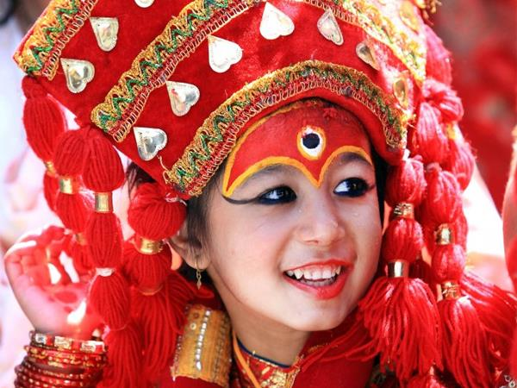

Day Seven
Your day begins at 4:30am. Your driver will take you to Nagarkot where you will watch the sun rise. Nagarkot is famous for its sunrise. After the sun has risen you will enjoy a light breakfast and then begin your hike.
The trail is downhill to Telkot, a magnificent sight as the sun bounces off the Himalayas and Mt Everest. You will pass agriculture fields as you make your way to one of UNESCO world heritage sites in Kathmandu valley “Changu Narayan Temple
Get your cameras ready to capture pictures of the 5th century temple. After exploring the temple, enjoy a light lunch before your driver takes you back to Kathmandu.
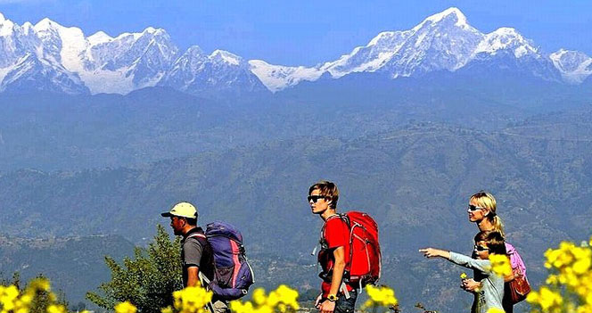
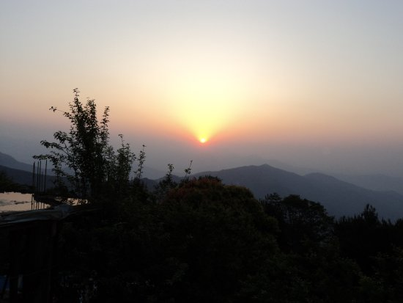

Day eight, nine and ten
Today you leave Kathmandu and travel 5 hours to Chitwan National Park which is located 160 miles South West of Kathmandu.
Chitwan is famous for its variety of wildlife especially the Great Indian Horned Rhinoceros and the Royal Bengal Tiger.
For 2 nights and 3 days you will go in search of birds, elephants, rhinos, tigers and crocodiles. Enjoy the jungle experience as local guides teach you about life in the park.

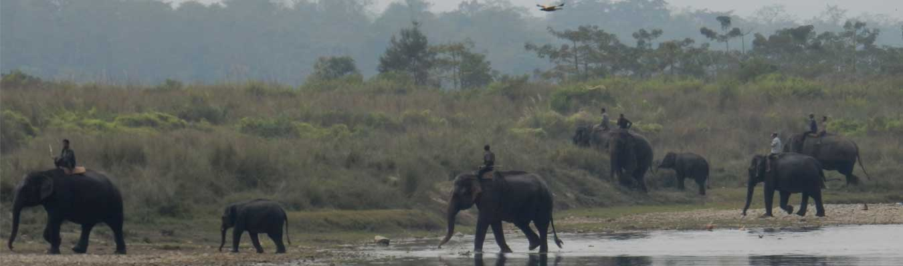

Day Eleven
After breakfast, you drive 6 hours to Pokhara and to the village of Bandipur. Bandipur is a hilltop settlement and a living museum of Newari Culture. This well-preserved town has many fine examples of 18th century architecture, as well as small cafes, shops and temples.

Day Twelve
Today we will tour the second largest city in Nepal, Pokhara. Laid out along a lake and surrounded by snow capped mountains this city is a paradise for photographers. You will take a private boat on Phewa Lake and then climb the World Peace Pagoda which will give us panoramic views of the city of Phokara and the lake.

Day Thirteen
Today is your day to wander the city of Phokara. This city has a laid-back mountain town pace. If you are feeling more adventurous there are day hikes up the steep hills surrounding the lake. Or fill yourself with delicious food like mixed chaat, samosas or pani puri.

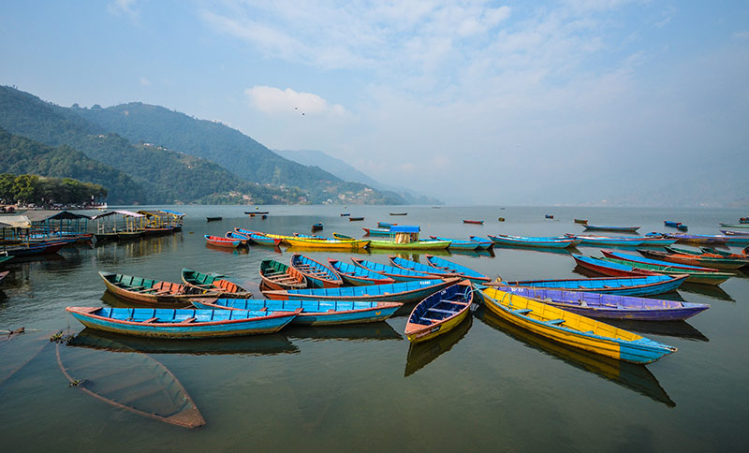

Day Fourteen
This morning you catch a flight back to Kathmandu where you can wonder the streets and take in the last of the city sights while you prepare to make your way back home.

Day Fifteen

An early start as our driver will pick us up in the morning and drop us at the airport for our flight home.
+++++++++++++++++++++++++++++++++++++++++++++++++++

Total cost: $1350.00 Canadian dollars

Included:
- Transportation in and around the country
- All hotels
- Accommodation while volunteering
- All meals while volunteering (breakfast, lunch and dinner)
- Volunteering costs
- Breakfast is included in all accommodation while travelling.

Additional Costs NOT included
- Meals (aside from while we are volunteering)
- International flights
- Tipping
- Alcohol
- Water and snacks
- Food you wish to buy for the local children (optional)
- Items of a personal nature
- Souvenirs

Q – How long before we leave should I book?
A - We have spots for maximum 12 people, so the sooner you book and pay a deposit, the sooner we can confirm your place on the team.

Q – Do I have to book my accommodation while travelling through Saving The Hungry?
A – If you would like to keep your costs down we suggest you book your accommodation through us. Saving The Hungry has negotiated lower rates with the local hotels.

Q – Do I need to stay with the team while volunteering?
A – Yes, this is not optional! Everyone needs to stay together to make it convenient for our partners to transport us.

Q – What deposit do I need to pay?
A – 30% deposit is required to book the hotels.

Q – When is the final payment due?
A – Final payment is required 45 days before you leave.

Q – Will I get my deposit back if I cancel?
A – No sorry deposits are non-refundable.

Q – Do I need a visa to travel to Nepal?
A – Nepal makes things easy for foreign travellers. Visas are available on arrival at the international airport in Kathmandu and at all land border crossings that are open to foreigners, as long as you have passport photos to hand and can pay the visa fee in foreign currency (some crossings insist on payment in US dollars). Your passport must be valid for at least six months and you will need a whole free page for your visa.

Q – What is the average cost of eating and drinking in restaurants?
Restaurants | Average
Meal, inexpensive | 180 - 300 NR
Meal, mid range restaurant | 500 – 1250NR
Domestic Beer | 180 – 325NR
Cappuccino | 142NR
Coke | 46NR
Water | 21NR

Q – What is the Nepal currency and conversion rate?
A – The Nepal currency is the Nepalese rupee (You can exchange Canadian dollars in Nepal at banks and money changers) For 1 Can $ you will get around Nepali Rupees NRs. 70
A – Most places in Nepal take US and Canadian dollars. If you are paying in US or Canadian, expect to be refunded in the local currency.

Q – How much money should I budget on spending a day?
A - $40 Canadian Dollars per day would be a realistic budget (additional sightseeing, liquor and souvenirs excluded)

Q – How much do I tip?
Y - Trekking guides, cab drivers, waiters and porters generally expect a tip of 10-15% for a job well done.

Q – What kind of accommodation can I expect?
A – Lodging is clean but very simple and rustic. Several of the rooms have nothing more than a bunk bed, ceiling fans and a shelf. This is not meant to be a 4-star experience!

Q – Is Nepal hot?
A –Nepals climate is influenced by maritime and continental factors, and has four distinct seasons. Spring lasts from March to May, and is warm with rain showers, and temperatures around 22°C. Summer, from June to August, is the monsoon season when the hills turn lush and green.

Q – Is Nepal safe?
A - It is very safe. Nepal feels safer than most other countries around the globe, possibly due to the religious nature of the people and their natural kindness. ... The Nepalese accept that tourism is a mainstay of the economy, and are very welcoming.
Like any other developing country, you should still be cautious and travel in groups in the evening.

Q – What tours would you recommend?
A – The tours that we recommend are all built into the cost of the itinerary.

Q – How will I get around?
A – From arrival to departure all your travel is taken care of.

Q – What kind of clothing should I bring?
A – We will send you a list of suggested clothing and items to bring 30 days before you depart.

Q – What vaccinations will I need?
A - Typhoid, rabbis and Hep B and A are highly recommending. Please contact your local health authority 60 days before you travel to set up an appointment to ask about vaccinations.
Q – Who do I contact if I want to join a team or would have more questions?
A – Please contact Nigel Bragge at nigel@savingthehungry.com or danielle@savingthehungry.com

.

